CQWE 2013 Release Notes

**Date**: 9/28/2013

**Author**: N4HAI

Notes:

1. “Now” button removed from registration window
2. Contest Year entry in registration window is updated to current year when the window is displayed.
3. Settings file updated with 2013; no other changes were made
4. User guide is branded “2012”, but no changes were made to the application other than 1-3 above.

CQWE 2012 Release Notes

**Date**: 9/23/2012

**Author**: N4HAI

**Purpose:** This document was compiled from feedback after the initial 2011 version. Feedback is highlighted. Features listed in this document were introduced in version 2012.0

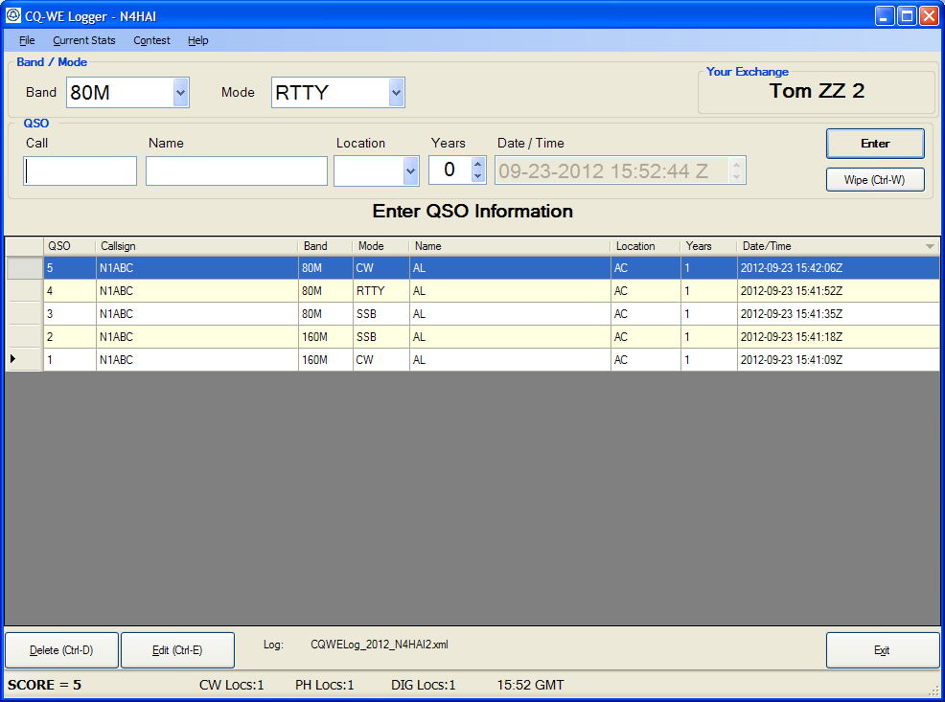

Contents

Changes Made Without User Input 3

From Tom, W2EQ and Peter, WA1VMI 4

From Bob - W3CRZ 4

From Bob, W2VE 5

From Tom, W2MN 6

From Bill, WS6K 6

From KD8WK 7

# Changes Made Without User Input

1. Updated program version – 2012.0
2. Installation now adds a Desktop Icon; can be removed manually; the free installer is limited, so auto uninstall of old version is not (yet) possible. Future versions may support uninstall/overwrite.
3. Added warning about not being the correct contest year; program will allow all previous years to be entered, but not future years. If registry info year does not equal current year, a warning will be displayed each time app is launched
4. If HRD is successfully configured, and the OK button is clicked on the config window, the program will remember that and display “HRD is not running” if you don’t turn it on. It will not turn on automatically when the app is launched; this will reduce errors: “The logger appears to hang when I launch it; I configured HRD and then something happened, and HRD will no longer launch”
5. Made buttons at the bottom a little smaller / general GUI cleanup
6. Added “this cannot be undone” when deleting a QSO
7. Added “Wipe” feature (ctrl-W or alt-W) to wipe QSO info to start over; the Wipe button will prompt the user: “are you sure that you want to wipe this QSO”. Using the menu or menu shortcut keys will not prompt the user.
8. Added “undo” (ctrl-Z) to undo the wipe; if any field is changed in the QSO fields, the buffer is cleared and
9. Dupe check looks only at QSOs with the current year. So, if previous year QSOs are in the log, they will not be counted.
10. When computing score, only QSOs with current year are used.
11. ADI export only exports QSOs logged in the current year. The XML log, however can store QSOs from any year.
12. After sensing a DUPE, the mouse may now be used to drop down band/mode; only F2/F3 worked previously.

# From Tom, W2EQ and Peter, WA1VMI

- Default date and time to that of last entered QSO when performing manual entry of QSO's after the contest. This allows an easy minor change to minutes or hours in most subsequent entries. (Already done in version Tom Foy is holding..)

DONE – check box “Use System time when entering QSO” is now a menu (beta version was check box in window)

# From Bob - W3CRZ

DONE· K8RSP made an error in entering his years of service in the setup and could not correct it afterword. Next year, working hams and ZZ station will want to increment this number.

Fixed bug in Registration window that sometimes caused an error while saving new values

**DONE** · There are eligible hams that have over 50 yrs service so you may want to increase the max value; **increased to 75**

**DONE** · At the bottom right of the screen, there is a message box with confusing (?) messages that appear to have little or no value. Also, spacing for locations worked is not big enough when the number of locations is 10 or more.

Removed all except error messages; could not duplicate LOC > 10, even with large fonts on Win XP

·DONE If you setup to use the HRD link, I would like to see a warning if you start the program again and the feature is not completely active. I got burned once, when I restarted the program and did not start the link to HRD.

Only shows HRD status warning if it was previously set up; this cannot be undone – message will always be displayed if HRD was set up

NOT DONE· A possible dupes warning when you are entering a call would be nice. To check for dupes now, you must enter the call and tab to check.

During development in 2011, it was decided that dupe error messages would display after entering the complete call and exiting the field (tab or click into another field)

· I would like to see a little more info in the ADI export. I export to my station log. Name, QTH for loc, and SRX for years would be nice. See standard ADI definitions.

DONE – added header and app specific information to QSO record:

Header Info:

<STATION_CALLSIGN:5>N4HAI

<MY_NAME:7>Tom Foy

<MY_STREET:16>338 Hampton Park

<MY_CITY:11>Westerville

<MY_STATE:2>OH

<MY_POSTAL_CODE:5>43081

<APP_CQWE_VERSION:10>2012.0.0.0

QSO Additional Info:

<call:4>N1AA<band:3>15M<mode:3>SSB<qso_date:8>20120708<time_on:4>1800**<APP_CQWE_NAME:2>AL<APP_CQWE_LOCATION:2>AE<APP_CQWE_YEARS:1>1**<eor>

NOT DONE · It would love to be able to import call signs from programs like cwget, mmvari, mmtty, etc. I expect that is far too complicated for now.

Import will probably not happen soon

# From Bob, W2VE

**DONE** I heard several operators complain about dupes and/or missing QSOs including you, The CLEAR Button may be to close to the ENTER button, either the logger is losing QSOs or people are selecting the CLEAR button instead of the ENTER

**Removed clear button; have to use menu; can’t use F keys to log / clear; other F key functionality exists, i.e., change band**

**DONE** When a dupe occurs it would be nice if the logger could display the QSO number and maybe have a QSO button to jump to the QSO. This would quickly show dupe info.

Added Info about QSO: Date, Number, Name, Location, Years of Service

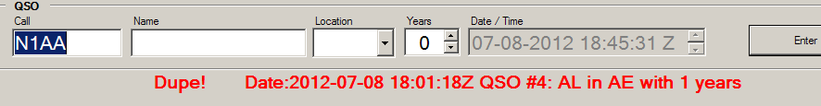

It would also be nice if a new view option that would only show the stations worked for the band that I currently have selected, instead of stations on all bands work. When I used the band column button I could only bring 10m and 80m to the top of the window. Of course the QSO number would not change and be fixed.

NOT done; time constraints, nice feature though

A new "Need" feature where you could enter call signs into a small window that could keep track of station that you heard and still need. This doesn't need to be use during one of those list runs, I think folks are doing this on paper right now. For example I heard station xyz on 10 meters, I enter xyz into the need list, it tells me that is not a dupe, it helps me remember that there a station xyz that I need, it will also allow me to enter the exchange for xyz and flag or multipliers that I need. This would replace the current usage of checking a call sign by typing in a call sign followed by tab and then manually writing down station still needed on paper.

NOT done; time constraints, nice feature though

# From Tom, W2MN

1. A couple of times an entry was flagged as a "dup"; it would be nice to have a button to push which temp called up the "dup info" (maybe in red with no ability to save it again) or simply temp moved to the spot in the log for the dup.

Add’l Dupe info given on screen

2. Because I was in / out, I shut off the log / computer several times, it would have been nice to have the log band/mode startup where I left off rather than go to the startup default band / mode.

Done – remembers last band/mode

# From Bill, WS6K

Last year I used HRD/DM780 and ran RTTY during the digital portion of the contest. I entered the Loc Code and Year in the Rcvd Exch Field. After the contest I printed off a copy of the DM780 log and entered the contacts into the logger. Any chance you could add the capability to import an ADIF file into CQ-WE Logger? I realize the Loc Code and Year might not be easy to capture, no problem I could edit the records after they are imported. Having all the other fields imported would save a lot of typing.

**Not done; nice to have, but importation will be too time consuming; perhaps a future version**

**DONE** Would like font sizes of entry fields increased. (I suggested changing the windows fonts, I don't see this as needed - W2EQ.) **Increased to 16 pt**

# From KD8WK

A couple nits and comments:  
+ I had to manually remove old logger before installing the new one.  
 It would be nice if the installer automatically directed you to the  
 deinstaller of the old program if necessary.

Can’t fix - Limited functionality with free installer; documentation indicates that old version must be uninstalled.   
  
+ Once the prior version was removed, the install was painless.  I did,  
 however, have all the prerequisite software installed, so no need to  
 hassle with that this time.  Thus, this part of the install wasn't  
 tested.  
  
+ After invoking the program, if you edit an existing entry, the changes  
 are not reflected in other entries involving the same call, nor is any  
 warning issued that there may be other entries which need to be changed.

Maybe in a future version; design decision from initial version  
  
+ Personally, I'd prefer that the "Wipe" option not require confirmation,  
 or make it an option.  This is especially true now that the CTL-Z undo  
 option is available.

Only button Wipe asks for confirmation; the menu selection / shortcut keys (ctrl-w / alt-w) don’t ask for confirmation  
  
  
+ If the program is reporting a Dupe, there are some things you can do  
 and others you cannot do in this mode, and these don't really make much  
 logical sense.  For instance, you can use F3 to cycle through the Modes,  
 but you cannot change the mode using the dropdown menu in the window.

Fixed  
  
+ Just found: If you enter a call, then use F3 to cycle through the modes  
 to a different mode (say, CW -> SSB), you can then save a DUP without  
 the program detecting the fact.  May require more experimenting to  
 quantify...

Can’t reproduce